Sisterhood Congregation Beth Ohr

Contact: Liz Arroyo

Tel: 732-257-6010

Email: MikeLizA3@comcast.net

FOR IMMEDIATE RELEASE

Lady of the Civil War – A Historical Production by Alisa Dupuy

Sunday, November 13, 3:00 P.M.

CONGREGATION BETH OHR, 70 RTE 516, OLD BRIDGE, NJ

Imagine yourself in the presence of a woman who lived during the American Civil War and who is willing to tell you all about the life, times and adventures she had during that period in American History. Through the performance of Ms. Dupuy, you will be transported back in time to the 1860s where, in authentic attire and persona, you will be regaled with tales about her life.

The Ladies of History, run by Alisa Dupuy, is a labor of love that grew out of a desire to  study history, wear the fashions of different eras and bring history to life in a lively and fun way.  History doesn’t have to be boring! The main goal of The Ladies of History is to make history fun, exciting and memorable for the guests who attend the shows.

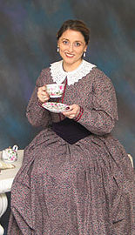

Refreshments, including a Dessert and Fresh Fruit Buffet, will be served.

Tickets are $18 in advance and $20 at the door.

All community members are welcome.

For further information, please contact Ilene Gray 732-390-5017 or Liz Arroyo, 732-257-6010.

# # #