Grandparents circle

￼

Facilitated by

rabbi joel Mishkin and

Rabbi ari Saks

November 8, 15, 2015 and January 10, 2016

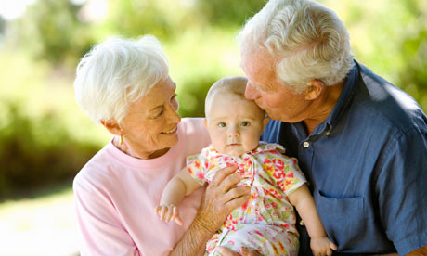

This is a three part series of workshops designed for Jewish grandparents with intermarried children to provide them with support and information in navigating the issues of intermarriage and foster positive relationships with their grandchildren. The program will take place on three Sunday mornings from 11:00 am to 1:00 pm. Class size will be limited and it is highly recommended that participants attend all sessions. There is no charge for this program and it is open to members and non-members of the congregations. The series is being funded through a grant from the Jewish Federation in the Heart of New Jersey. Please note: November 8, and January 10 at Congregation Beth Ohr, and November 15 at Congregation Beth Mordecai in Perth Amboy. Please RSVP with Phyllis Greenberg at 732-257-1523.